ADDENDUM 2

To: All Proposers
Project: RFQ/P-24-007 CalShape HVAC Assessment Services
Date: April 10, 2024

NOTICE TO PROPOSERS
This Addendum forms a part of the Request for Proposals (RFP) and modifies the original documents. It is intended that all work affected by the following modifications shall conform with related provisions of the RFP.
The purpose of this Addendum 1 is to extend the due date, and to provide information and clarification for submitted questions for the RFP 24-007 for CalShape HVAC Assessment Services.
GENERAL NOTES
The revised due dates/times for RFP 24-007 are as follows:
Due date for Proposals Friday April 19, 2024 by 4:00 pm Pacific Time

Request for Information and Clarifications for Submitted Questions
Q1. I checked the RFP and the website, but only saw the list of schools in scope. Can you please provide information regarding the number of units, number of filters, and the number of classrooms at each site? That will allow us to make the most accurate bid for this work.
A1. Please see attached list (Pages 3 - 9)
All information provided on the attached list will need to be verified by the selected vendor.

Q2. Do you have a list of HVAC equipment?
A2. Please see attached list (Pages 3 - 9)
All information provided on the attached list will need to be verified by the selected vendor.

Q3.Do you have as-built drawings showing which unit serves which space? Mechanical drawings with equipment schedules and floor plans are best.
A3. Not available at this time.

Q4. CalSHAPE wants calculations for filter replacement related to pressure drop verification. Since filter replacements are not included in this RFP, will this be an add after the initial phase?
A4. This will be available at the next phase. - See explanation below

Q4.Per Addendum #1, and the RFP language, you state that Filters and CO2 monitors are not included. However, based on our research and knowledge, the District has not yet applied for funding for these six schools. Is this RFP for assessments only, or is it to also include the application process? Per the CEC, all three scopes of work must be complete to receive full phase 1 grant funding (assessments, filters, AND CO2, plus optional program contingency). Please clarify the intent of this RFP process and our scope of work so we can best respond to you.

The District will have difficulty applying for phase 2 upgrade grant funding if the proper procedures are not followed or applied for, per the State of California requirements.
A4. The initial phase will consist of the assessments for each site followed by filter replacement, CO2 Monitor inspection/installation and application submission.

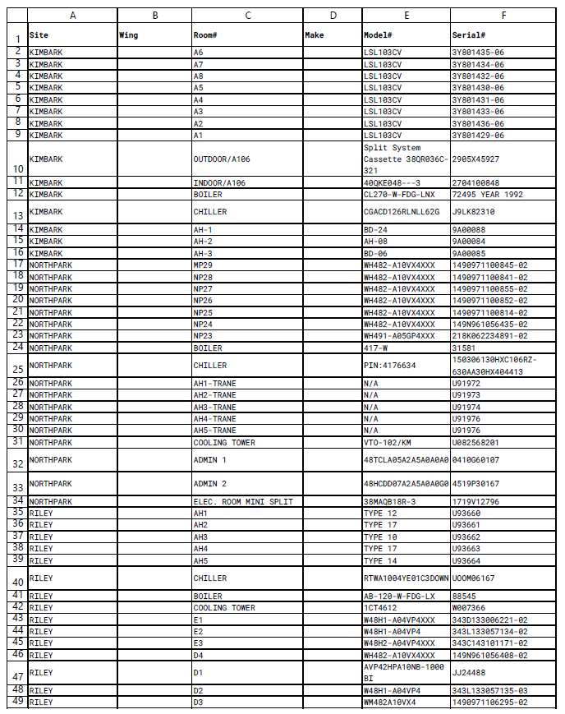

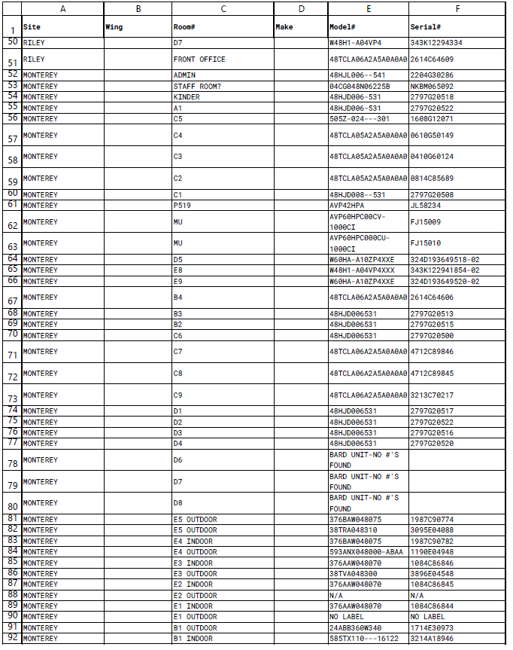

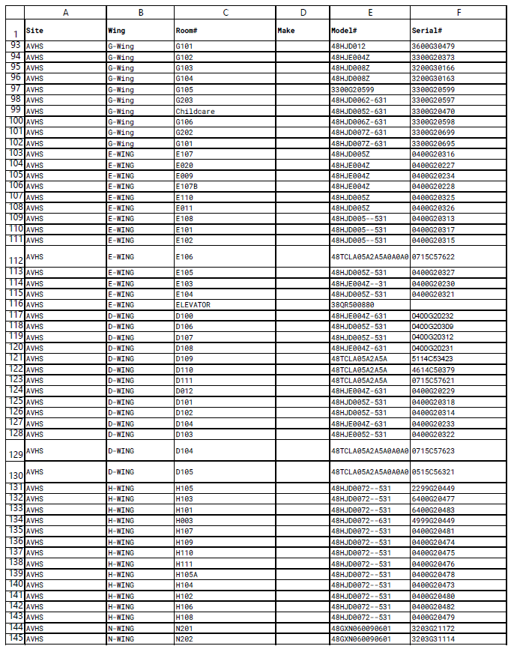

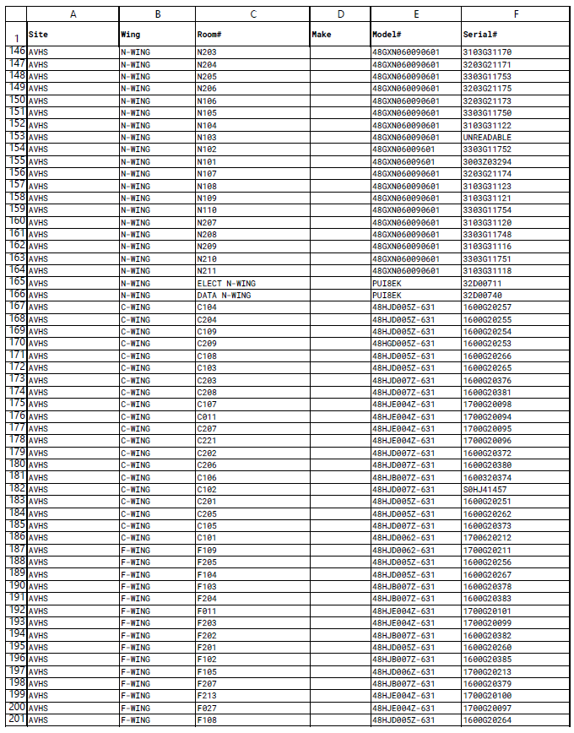
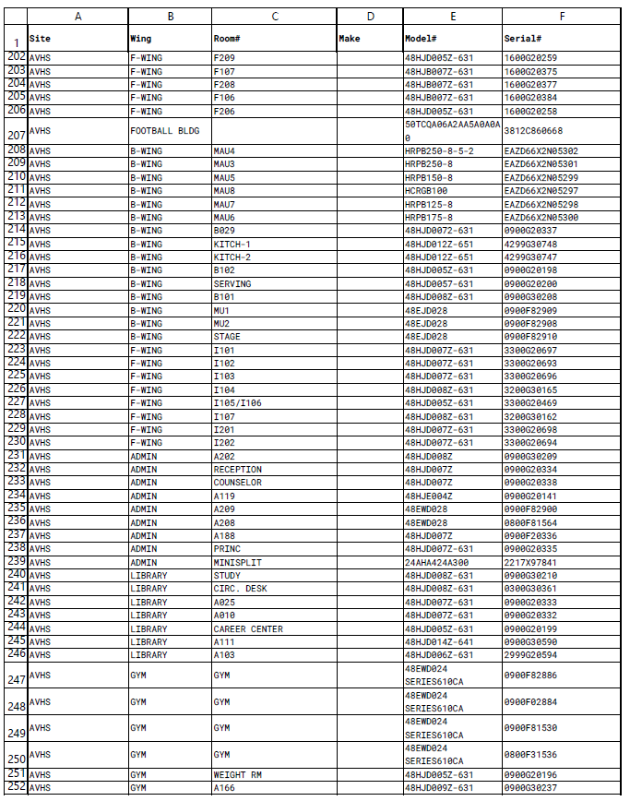

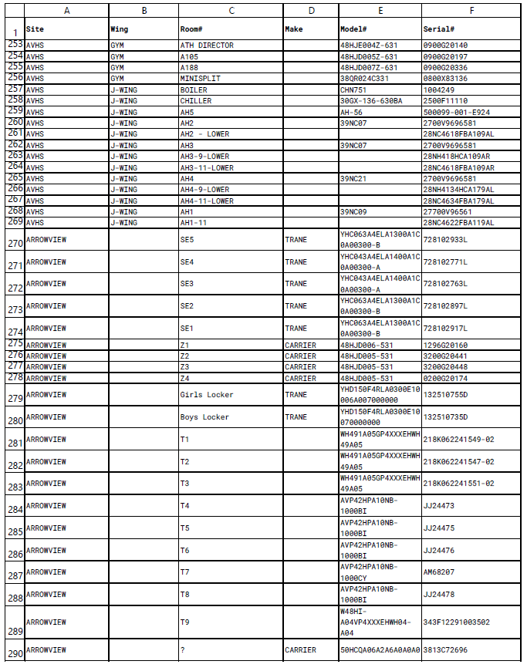
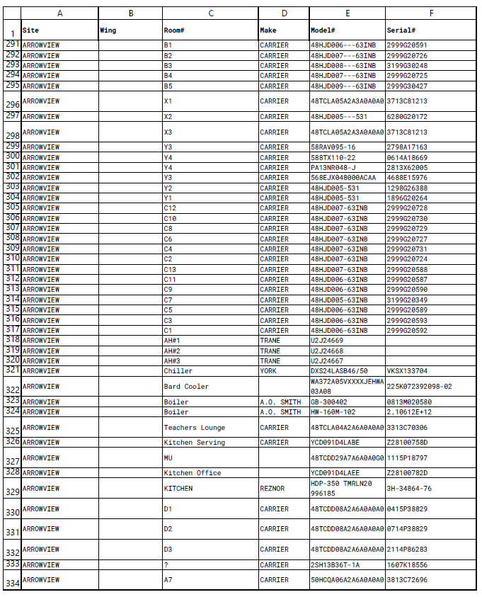
End of Addendum

